Interior Point
# Source: AI Source: Provided by: [Data Path: Persons Table -> ID Column: 1, Name_En Column: Motasem Essam] -> From: [ChatGPT] on [7/25/2026]
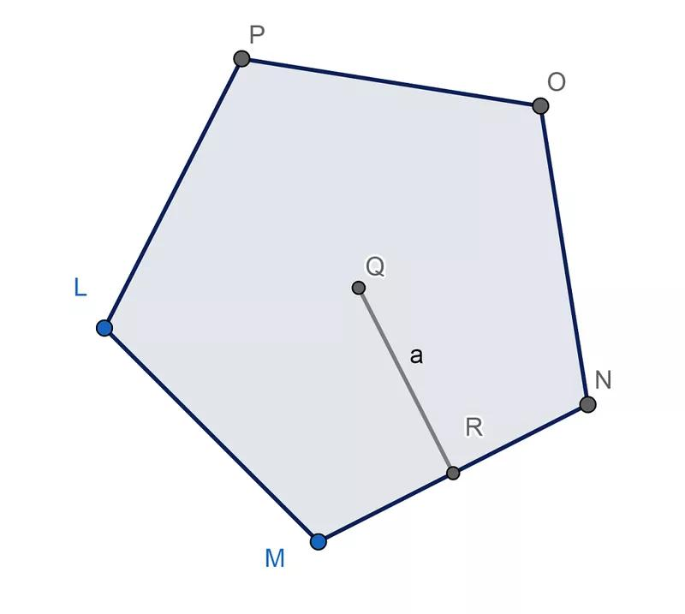
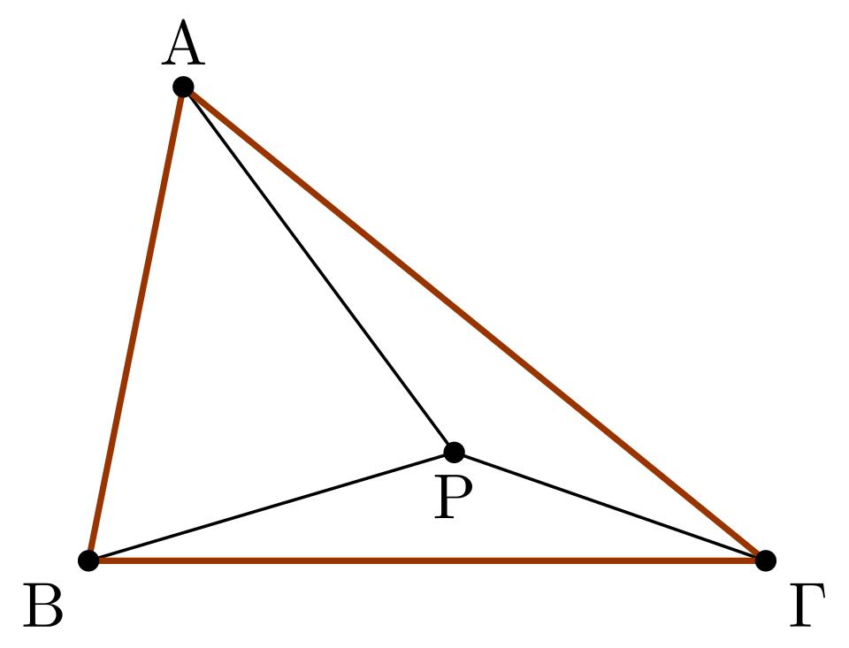
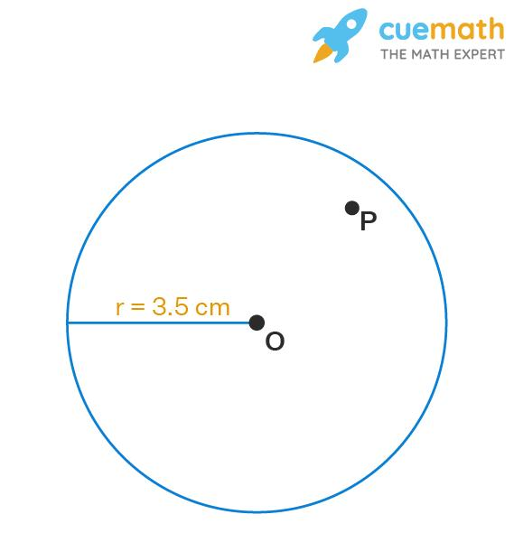
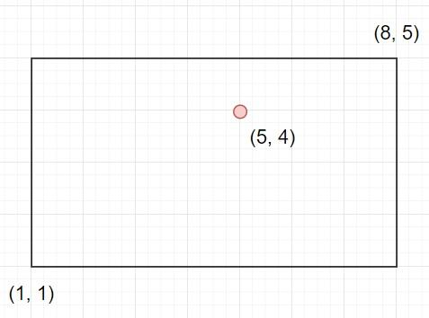

Definition
# Source: AI Source: Provided by: [Data Path: Persons Table -> ID Column: 1, Name_En Column: Motasem Essam] -> From: [ChatGPT] on [7/25/2026]
An Interior Point is a point that lies completely inside a geometric figure or region and not on its boundary (edge).
An interior point belongs to the interior of the figure and is surrounded by other points of the same figure.

Characteristics
# Source: AI Source: Provided by: [Data Path: Persons Table -> ID Column: 1, Name_En Column: Motasem Essam] -> From: [ChatGPT] on [7/25/2026]
An interior point:
- Lies inside a geometric figure.
- Is not on the boundary or edge.
- Is not outside the figure.
- Belongs to the interior region.
- Can exist in both two-dimensional and three-dimensional objects.

Illustration
# Source: AI Source: Provided by: [Data Path: Persons Table -> ID Column: 1, Name_En Column: Motasem Essam] -> From: [ChatGPT] on [7/25/2026]
Interior Point in a Triangle
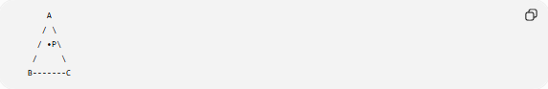
A
/ \
/ •P\
/ \
B-------C
Point P is an interior point because it lies completely inside triangle ABC.

Interior Point in a Circle

*****
** **
* • P *
* *
** **
*****
Point P lies inside the circle and is therefore an interior point.

Mathematical Description
# Source: AI Source: Provided by: [Data Path: Persons Table -> ID Column: 1, Name_En Column: Motasem Essam] -> From: [ChatGPT] on [7/25/2026]
For a geometric figure $F$:
A point $P$is an interior point if:
- $P$belongs to the figure.
- $P$is not on the boundary.
Symbolically:
$$P∈Interior⁡\left(F\right)$$

Examples
# Source: AI Source: Provided by: [Data Path: Persons Table -> ID Column: 1, Name_En Column: Motasem Essam] -> From: [ChatGPT] on [7/25/2026]
Interior points can occur inside:
- Triangle
- Rectangle
- Square
- Circle
- Polygon
- Ellipse
- Solid objects (interior region)

Properties
# Source: AI Source: Provided by: [Data Path: Persons Table -> ID Column: 1, Name_En Column: Motasem Essam] -> From: [ChatGPT] on [7/25/2026]
An interior point:
- Is surrounded by other points of the figure.
- Does not touch the boundary.
- May be connected to any boundary point using line segments.
- Is part of the measurable region (area or volume).

Applications
# Source: AI Source: Provided by: [Data Path: Persons Table -> ID Column: 1, Name_En Column: Motasem Essam] -> From: [ChatGPT] on [7/25/2026]
Interior points are used in:
- Geometry
- Computational Geometry
- Computer Graphics
- CAD (Computer-Aided Design)
- Geographic Information Systems (GIS)
- Robotics
- Mesh generation
- Collision detection

Advantages
# Source: AI Source: Provided by: [Data Path: Persons Table -> ID Column: 1, Name_En Column: Motasem Essam] -> From: [ChatGPT] on [7/25/2026]
Using interior points helps to:
- Distinguish regions from boundaries.
- Analyze geometric figures.
- Perform point-in-polygon tests.
- Model spatial relationships.
- Support computer algorithms.

Limitations
# Source: AI Source: Provided by: [Data Path: Persons Table -> ID Column: 1, Name_En Column: Motasem Essam] -> From: [ChatGPT] on [7/25/2026]
Interior points:
- Depend on the definition of the figure's boundary.
- May require computational methods to determine in complex shapes.

Comparison with Other Types of Points
# Source: AI Source: Provided by: [Data Path: Persons Table -> ID Column: 1, Name_En Column: Motasem Essam] -> From: [ChatGPT] on [7/25/2026]
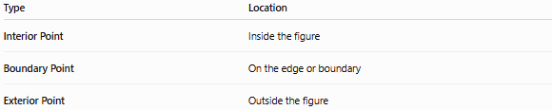
Type | Location
Interior Point | Inside the figure
Boundary Point | On the edge or boundary
Exterior Point | Outside the figure

Key Points
# Source: AI Source: Provided by: [Data Path: Persons Table -> ID Column: 1, Name_En Column: Motasem Essam] -> From: [ChatGPT] on [7/25/2026]
- An Interior Point lies inside a geometric figure.
- It is not on the boundary.
- It belongs to the figure's interior region.
- Interior points are important in geometry, computational geometry, GIS, CAD, and computer graphics.

Conclusion
# Source: AI Source: Provided by: [Data Path: Persons Table -> ID Column: 1, Name_En Column: Motasem Essam] -> From: [ChatGPT] on [7/25/2026]
An Interior Point is a point located entirely within the boundaries of a geometric figure, forming part of its interior region while remaining separate from its edges. Interior points are fundamental in plane geometry, computational geometry, engineering, computer graphics, CAD, GIS, and spatial analysis, where distinguishing between inside, boundary, and outside regions is essential for accurate geometric modeling and problem solving.

